Welcome to the Proposed Mountain Ash Wind Energy Project Public Engagement Session

About the Project
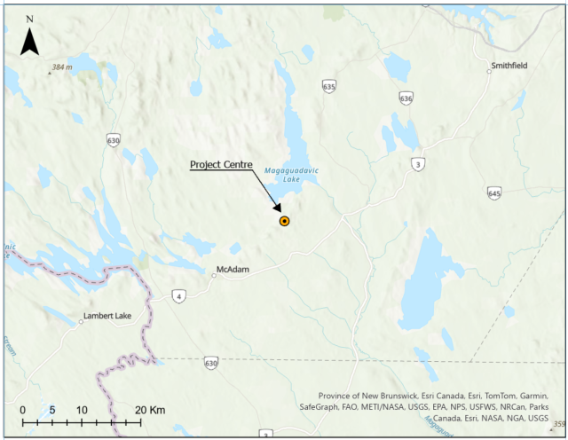
The Mountain Ash Wind Energy Project is a proposed renewable energy facility with a total capacity of 42 megawatts (MW). The project will be comprised of up to six wind turbines, which will be interconnected to the existing New Brunswick Power electrical transmission network. If built, the facility would be located on Crown land east of the Village of McAdam, in York County, New Brunswick. The project is being developed through a partnership including one or more yet-to-be-disclosed First Nation communities and SWEB Development LP (SWEB Energy), a Halifax-based renewable energy developer and operator.

About the New Brunswick Request for Expressions of Interest (REOI)

Following an initial procurement, NB Power has released a second round of Request for Expressions of Interest (REOI-XXXX-25-I34) in May 2025. This REOI aims to procure up to 200 MW of renewable energy, which includes energy sourced from wind, solar, and hydroelectricity, among others. This procurement aims to increase the inclusion of First Nations and Indigenous communities in the energy transition, while also working to lower energy rates for ratepayers in the province. Other benefits of this program include the creation of new jobs, business opportunities, and the development of expertise in the energy industry here in New Brunswick.

Project Benefits

A central focus of the project during development, construction, and operation is to ensure that as much local labor, services, and materials as possible are used. It is anticipated that if the project is built, it will create several direct and indirect benefits for various stakeholders and First Nation communities. The project will have a positive impact on local businesses, resulting in employment opportunities and generating tax revenue for municipal, provincial, and federal governments. Furthermore, a portion of project revenues will be allocated to support local community groups and underrepresented communities in the province.

Through this project, SWEB Development aims to collaborate with NB Power to enhance the inclusion and participation of diverse organizations in the energy sector, facilitating a transition toward a net-zero electricity system by 2035.

SWEB’s Approach to Wind Energy

SWEB Energy is a team of renewable energy professionals who are passionate about community, the environment and shared social values. As of 2024, our team has developed, commissioned and is currently operating 68 MW of community-based wind energy projects throughout New Brunswick and Nova Scotia, which includes the Wisokolamson Energy Project, an 18 MW wind energy project located on a tract of Crown land west of the Village of Riverside-Albert, New Brunswick. All of SWEB’s Canadian projects are owned in partnership with First Nation groups or local communities. SWEB is the Canadian subsidiary of W.E.B, an Austrian, community-owned energy transition company with over 30 years of experience in planning, financing, constructing and operating renewable energy projects.

SWEB Energy will continue to engage the community regarding the Project over the coming months. Our team will reach out directly to interested stakeholders and would be pleased to welcome community members at any of our upcoming engagement sessions. We also invite you to consult our Project website and social media channels for detailed information and updates; or simply give us a call!

Contact Us. Your feedback and questions are welcome!
SWEB Development
6080 Young St, Suite 403
Halifax, NS
B3K 5L2
Canada
Local: (902) 431-0564
Toll Free: +1 (844) 468 3134
Project Contact
Jason Parisé
Director of Development – Wind Lead
Phone: +1 (902) 4310564 ext. 261
Mobile: +1 (902) 329-1494
Email: jason.parise@sweb.energy

Website: mountainash.sweb.energy

